**Tharun Bejawada (191911509)**

**23.AUTOMATION TESTING USING SELENIUM TOOL FOR SHOPPING DOMAIN**

**AIM :**

To execute Automation testing using Selenium tool for shopping Domain.

**PROGRAM**

**package** sse;

**import** org.openqa.selenium.By;

**import** org.openqa.selenium.WebDriver;

**import** org.openqa.selenium.WebElement;

**import** org.openqa.selenium.chrome.ChromeDriver;

//import org.testng.Assert;

//import org.testng.annotations.Test;

**public** **class** amazon {

**public** **static** **void** main(String[] args) {

System.***out***.println("hai"); System.*setProperty*("webdriver.chrome.driver","C:\\CSA37 Lab details\\Sellinium and junit\\selenium jar\\chromedriver_win32\\chromedriver.exe");

WebDriver driver = **new** ChromeDriver();

//driver.get("https://www.google.com/");

driver.manage().window().maximize();

driver.get("https://amazon.com");

WebElement username=driver.findElement(By.*id*("txtusername"));

System.***out***.println(username);

WebElement password=driver.findElement(By.*id*("txtpassword"));

System.***out***.println(password);

WebElement login=driver.findElement(By.*name*("btnlogin"));

System.***out***.println(login);

username.sendKeys("8838647721");

password.sendKeys("#baba1610");

login.click();

}

}

**OUTPUT**

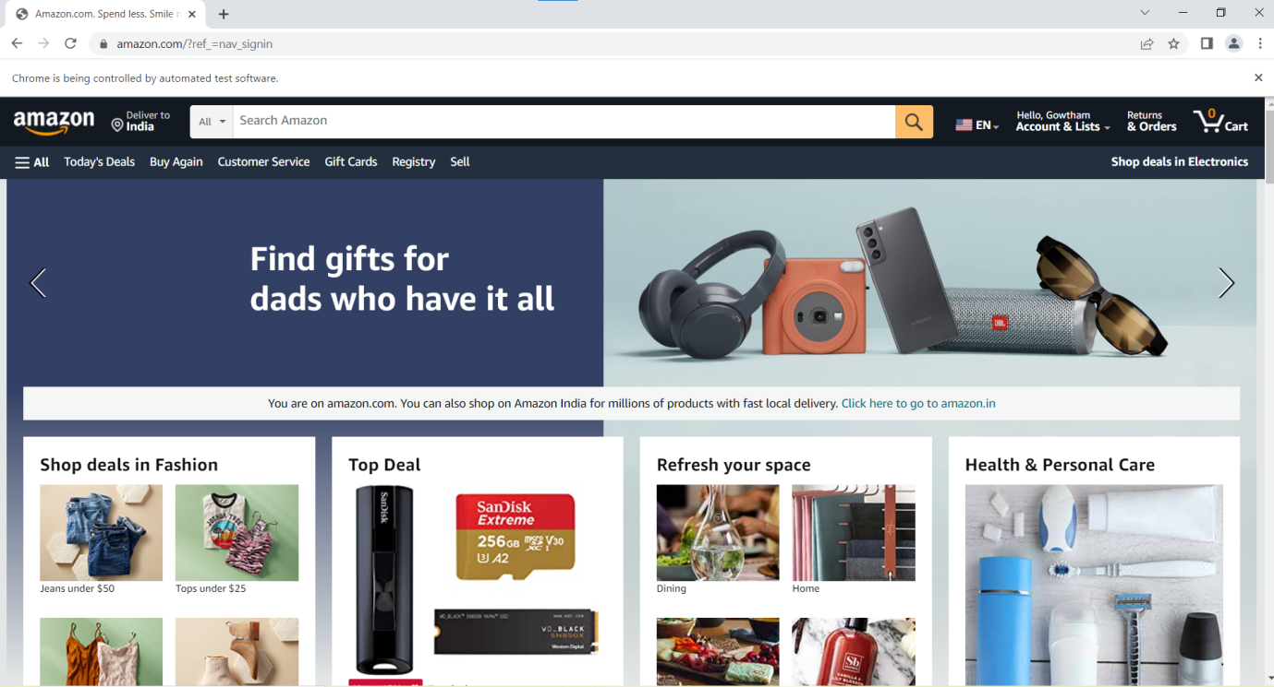

**RESULT**

Hence Automation testing for shopping domain is Executed successfully.